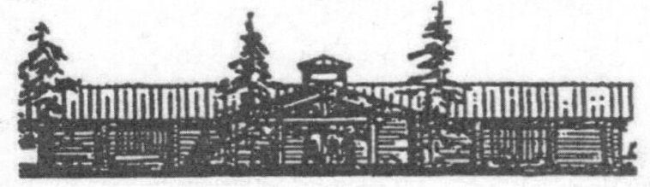

Johnson Heritage Post Art Gallery
115 W. Wisconsin St.
PO BOX 1293
Grand Marais, MN 55604
218-387-2314
jhp@boreal.org

The Johnson Heritage Post Selection Committee is interested in submissions from artists who are interested in exhibiting in 2019 - 2021 and beyond. Please understand that 90% of the artwork exhibiting must be available for purchase during a show. Johnson Heritage Post’s commission will be 30% of the retail price of each artwork in the 2019 year. The commission percentage is not guaranteed for the 2020 year and beyond.

To apply to exhibit please mail or email the following information:

- 8-10 photos of the work (digital, print, or CDs) you are interested in exhibiting. Please include the size and price of each artwork. There must be a price list included in the application or it will be deemed incomplete.

- Resume to include past exhibitions, awards, grants, education, teaching experience, etc.

- A letter of interest explaining why you would like to exhibit at the Johnson Heritage Post Art Gallery and how you heard about our gallery. Also, please indicate if you have exhibited at the Gallery in previous years including approximate dates.

- Your artist statement.

- Please include the year you would prefer to exhibit.

*If you are mailing your application please include a return addressed and stamped envelope.

